WHITE PAPER MAY 2019 | 1

ABC______________, INC

ABC, Inc’s Artificial Intelligence Tool
Face2Face
The Rosetta Stone for People’s Deepest Emotions

“What is most revolutionary about Face2Face is, that while it was developed as a behavioral health mapping tool to give clinicians insight into the degree of “wholeness” of an individual, specifically veterans with PTSD, as time went on we realized that the capabilities of this software technology are almost infinite. Face2Face is applicable to Force Readiness, Credibility assessment, Human Resources in both federal and commercial sectors and much much more.”

BACKGROUND:

We show our emotions in many ways such as our body language and vocal tones, but the most compelling way is through our facial expressions. People who are good communicators take advantage of this fact: They match their expressions to the feelings they want to convey. They control what they show. We watch each other’s expressions closely when we want to see if what we’re being told is sincere. With strangers our predictions of their thoughts and feelings are accurate roughly 20% of the time, with close intimates, like husbands and wives, the rate goes up to about 35%. The best among us, what at reading each other’s thoughts and feelings rarely reach 60% or better. ¹ Our deepest thought and feelings are easily kept secret from one another and, as it turns out, often from ourselves.²

Over time we’ve tried numerous ways to improve on these disheartening odds of understanding what we’re really feeling, of knowing if what we’re hearing is the truth. They range from the mechanical; The Lie Detector: measuring galvanic skin response, respiration, and heart rate; to the methodical: The MMPI that evaluates patterns of True / False responses to 566 questions based on the assumption that no one could keep track of that many answers well enough to fool the test; to the exotic and indirect: The Exner computer analysis of responses to the Rorschach Inkblot cards. All these methods have some degree of validity, but they also are all subject to the same three underlying problems: They are indirect measures of the emotions underlying peoples’ behavior. They are subject manipulation of one sort

WHITE PAPER MAY 2019 | 2

or another. And they were all vulnerable to human error in administration and interpretation. A perfect example is that a lie detector is very reliable unless you are testing a sociopath (who, of course would be more than likely to be the kind of person you’re trying to catch and therefore test). Sociopaths are notorious for defeating lie detectors because they don’t experience any stress when they lie.

In the final analysis, when people want to know what someone else is feeling, they almost always rely on their facial expressions. There is a constant stream of involuntary non-verbal communication flowing between us on our faces. These expressions of emotion that we see on one another’s faces, in typical interactions, last between half of a second to 4 seconds. They are classified as Macro-expressions, and we know people can control them. We often smile when we’re supposed to, but not because we actually feel like smiling. We frown at something we find funny but know is socially inappropriate.

However, while we are constantly communicating and assessing each other’s Macro-expressions, another whole layer of communication is occurring. We have Facial “Micro-expressions of Emotion (FMEEs) that last 1/15th of a second or less. These sets of involuntary facial movements and our neutral baseline always express the same 6 human emotions: Sadness, Fear, Anger, Happiness, Surprise, and Disgust. (See Fig 1 below).
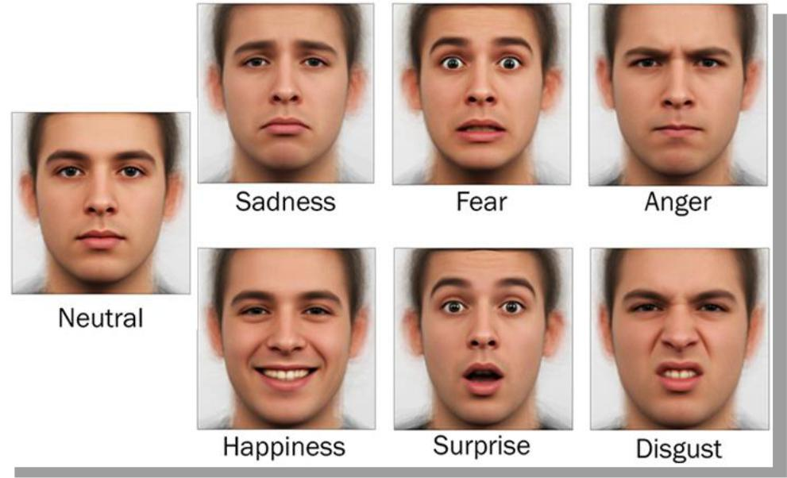

Fig. 1

Not only are these micro expressions consistently related to the same underlying feelings, they are also universal, as if they were hardwired into our DNA. As far back as the late 1960s serious scientific research was showing that the same 6 basic set of facial muscle movements reflect the exact same emotions, no matter where

WHITE PAPER MAY 2019 | 3

you are on the planet, no matter how advanced or primal your origins. (see Fig. 2 of a Fore tribesman in New Guinea showing Joy, Sorrow, Anger, and Disgust).³

Fig. 2

Since the sixties a large body of work has been developed using analysis of facial expressions to increase effectiveness in marketing (relatively crude measures of emotion are typically used for this purpose), or for more sophisticated purposes such as predicting. For example, trying to determine the predisposition of jurors to find defendants guilty or innocent (using very sophisticated analysis of potential jurors’ facial expressions by highly trained experts observing them in person, or even reviewing still photographs from their social media pages)⁴.

Facial micro-expressions of emotion have been adapted to such diverse uses because they reveal the true feelings behind our words even when we’re trying to conceal them. But even with the use of analysis of facial emotions to establish emotional status, credibility, or to predict behavior we were still relying on the inconsistent skills of the human observer. Hence there was no way to tap the full potential of FMEE’s. Until now.

THE HISTORY OF FACE2FACE:

It all started with the critical need for more efficient and more effective triage,
diagnosis, and forms of treatment for Post-Traumatic Stress Disorder and other

mental health conditions affecting veterans. At that point we had already lost more
American soldiers coming back from the War on Terror to suicide than we had in
combat. Approximately 30% of troops deployed to Iraq and Afghanistan between
2001 and 2010 eventually developed mental health conditions serious enough to

require treatment. As of 2012 less than 50% of returning veterans with PTSD were
receiving mental health services. Despite multiple mandates to use therapies that
have been proven effective, 70% of the care being provided was not evidence
based. Today the annual cost of PTSD care for veterans is roughly
$1,300,000,000. Despite that enormous outlay of money, and the efforts of

WHITE PAPER MAY 2019 | 4

committed healthcare providers, 68 veterans from all wars attempt suicide per day, 18 to 22 successfully.

Treating combat related PTSD patients is challenging on many levels. Therapist’s caseloads are frequently overwhelming, their evidence for making diagnostic decisions is primarily observational and patient-reported data, their patients either don’t report, or under-report their symptoms until they are severely ill because they have learned to be stoic on the battlefield. ABC Inc was founded in Washington, DC in 2012 to address the obvious need for a practical biometric gold standard based on hard data to help clinicians provide efficient and effective care for their PTSD patients.

Over the next five years ABC developed, first the methodology and then the technology to launch its revolutionary Artificial Intelligence Technology, Face2Face. By 2019 the Face2Face software technology tool has become a game changer not only in the area of Behavioral Health but other markets as well such as Security and Human Resources. It produces a 3-dimensional model of the subject’s face (See Fig. 3), compares it to the structure of all 6 universal emotions and the subject’s neutral baseline, then compiles, and presents a readout of FMEEs for every1/30th of a second of video captured. It’s 80 to 85% accurate for each FMEE classified.

With the data from the readout, it produces an “emotional footprint” for subjects’ feelings on any given topic, a data set and graphic representation of how their emotions flow and interact with one another, and a record of which topics or experiences activate or “trigger” their emotions.
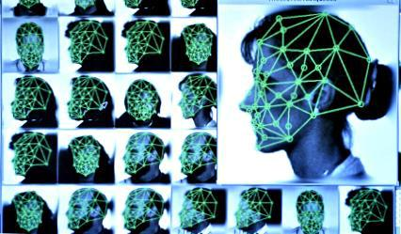

Fig. 3 Getty
Images

WHITE PAPER MAY 2019 | 5

To work at this level of sophistication, facial expressions of emotion have been broken down into the movements of 65 numbered muscle groups in the face (called Action Units or AUs) and their combinations. Examples of AUs are presented below in Figs. 4 and 5.
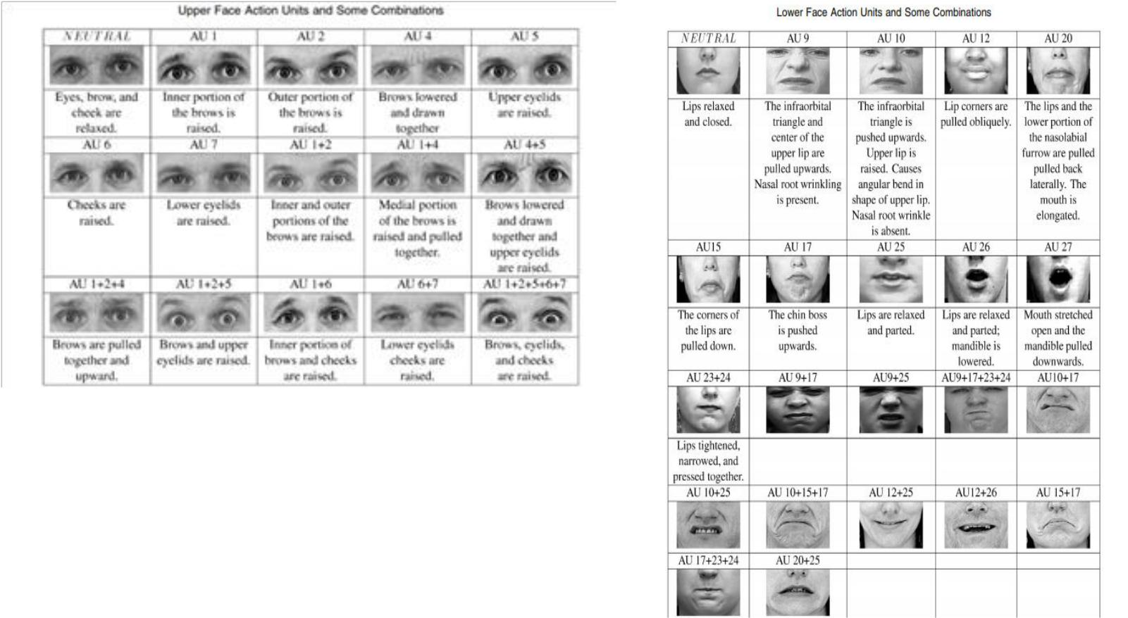

Fig. 4 Fig. 5

Facial Micro-expressions of emotion have been adapted to such diverse uses because they reveal the true feelings behind our words even when we’re trying to conceal them with false Macro-expressions. The behavioral health scientists and software engineers working on Face2Face recognized that since FMEEs are involuntary expressions of unfiltered emotions, they very well might serve as the kind of biomarker that’s been missing in mental health diagnostics and treatment as well as other human resource applications.

Face2Face goes far beyond the mere classification of emotions from social media photos. Feelings aren’t static, they’re dynamic and fluid, reflecting both our personalities and how we’ve learned to respond to different situations.⁵ Face2Face

WHITE PAPER MAY 2019 | 6

reflects that reality in the way it treats FMEE data: It produces an overview of the individual’s overall emotional status (resilience), their emotional valences toward certain situations (reactivity and/or bias), and which emotional reactions and defenses are unconsciously mobilized when they experience stress (coping styles / personality traits).

This analytical technology literally maps the ever-changing human emotional landscape on the basis of hard data. Currently its assessments of an individual’s resilience, reactivity, and coping style, are driven by comparisons of their responses to different topics compared to their own baseline (neutral) reactions. It also uses comparisons of an individual’s reactions to stimulus pictures with nationally based norms. Face2Face’s integrated neural-network machine learning is designed to improve its accuracy in those areas continuously.

Moreover, its machine learning is not limited to self-correction. It is designed to compile an ever-expanding database and set of emotional interactions and behaviors it can detect or predict. As its store of data grows it will be able create algorithms for almost any purpose.

Face2Face uses a telehealth platform. The technology can be used to measure patients’ emotions in the same room, or half way around the world. it is logical that the better the quality of your video feed, the more reliable the information you will get from the program. That being said, on occasion we’ve had to improvise. In one instance we made do with a video feed from a cell phone in a moving car at night and in another, we run the program through washed-out, backlit feed from a laptop. We’ve even videotaped a session back-lit by full sunlight filtering through a white nylon tent, in Afghanistan.

WHITE PAPER MAY 2019 | 7

At a minimum, the video image quality needs to have enough definition to scan and capture on tape the 65 facial muscle groups, those Action Units (”AUs”) previously described. The quality is necessary because the Face2Face program produces a 3-dimensional model of the subject’s face (See Fig. 6) reacting to a standard grey screen neutral stimulus for 5 seconds.
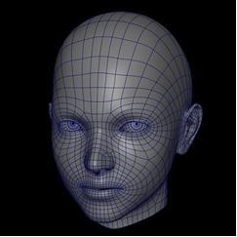

Fig. 6

Using the neutral model as a baseline for that individual, the program then compares the activation of the different sets of AUs with those associated with all 6 universal emotions every 1/30 of a second of video captured. It calculates a probability that each set of a subject’s AUs matches to one of the 6 universal emotions, neutral, or is unclassifiable. That produces a data array (see Fig. 7).

Timestamp in 1/1000 " | Angry | Disgusted | Fearful | Happy | Sad | Surprised | Neutral | % Classifiable
33 | 10 | 6 | 16 | 3 | 30 | 1 | 32 | 98
66 | 11 | 8 | 21 | 3 | 30 | 1 | 24 | 98
100 | 9 | 5 | 15 | 2 | 29 | 1 | 34 | 95
133 | 8 | 6 | 17 | 3 | 31 | 0 | 32 | 97
166 | 10 | 6 | 16 | 3 | 31 | 1 | 30 | 97
200 | 11 | 6 | 17 | 2 | 29 | 1 | 30 | 96
233 | 10 | 5 | 17 | 2 | 29 | 1 | 32 | 96
267 | 10 | 6 | 16 | 4 | 28 | 1 | 31 | 96
300 | 10 | 5 | 15 | 2 | 27 | 1 | 36 | 96
333 | 9 | 5 | 15 | 2 | 30 | 1 | 34 | 96
367 | 9 | 6 | 16 | 4 | 27 | 1 | 35 | 98
400 | 10 | 5 | 17 | 2 | 29 | 1 | 33 | 97
434 | 11 | 6 | 18 | 2 | 28 | 1 | 30 | 96
467 | 8 | 6 | 18 | 3 | 32 | 1 | 30 | 98
500 | 11 | 7 | 16 | 3 | 32 | 0 | 27 | 96
534 | 7 | 6 | 16 | 3 | 31 | 1 | 33 | 97
567 | 8 | 6 | 17 | 3 | 29 | 1 | 34 | 98
Aggregated FMEEs | 9.5 | 5.9 | 16.6 | 2.7 | 29.5 | 0.9 | 31.6 | 96.8

Fig. 7

WHITE PAPER MAY 2019 | 8

Each of the readings for an individual FMEE data point is 85 to 90% accurate.

We’ve collected FMEE data from any number of sources including open-ended clinical interviews, a semi-structured interview focused on PTSD, responses to a standardized and normed set of stimulus photos, and even videos of televised broadcasts. Whatever the source, if we are able to videotape an entire assessment the aggregated data will capture a patient’s overall “Emotional Footprint”. By “Emotional Footprint” we mean an overview of what the person’s predominant emotions are at that point in their life.

REAL WORLD APPLICATIONS OF FACE2FACE

TWO CASE HISTORIES:

CASE HISTORY ONE: LANCE CORPORAL T.

Case One: A Marine deployed in a remote area overseas. This case demonstrates how Face2Face creates a way to address the almost elemental problem of our disconnection from one another’s feelings as well as our own and applies not only to Force Readiness but also to emotional healing. The Face2Face unit, based in Washington D.C., was used to help a Marine who was experiencing PTSD, understand what was going on within himself and cope with his symptoms while deployed in Bucharest, Romania.

As human beings we are locked inside the experience of our own lives. No one else can truly know what we have experienced in the past or are now experiencing, and the unique meanings we attach to these experiences whether past or present. Our expectations and assumptions about one another, and ourselves can prevent us from even recognizing our own feelings or experiencing what is real or true in our lives as we live them. Typically, we understand others’ actions and feelings because our world view gives us an explanation for why others act a certain way. These boxes we create can make life more difficult rather than easier. We can’t always understand or even register our inner most feelings or actions if they are dramatically out of keeping with our view of the world or who we think we are. Lance Corporal T was in trouble for this very reason.

Lance Corporal T. was suffering from insomnia and unshakable feelings that his wife would be unfaithful to him during his absence or that something bad was going to happen to his 8-year-old son. He had no reasons to doubt his wife’s fidelity. In fact, there were many reasons to believe in her loyalty. There was no real or present danger to his son. And yet his jealousy and fears left him no peace. He requested a Face2Face interview, both as a volunteer to help his comrades at arms who had PTSD, and in hopes it might help him find some relief from his symptoms.

WHITE PAPER MAY 2019 | 9

He could think of no reason why he was having the problems he was. He had certainly seen some brutal combat; he had lost members of his unit with whom he had bonds as close as with family; but he had “managed all of that” while he was deployed to Afghanistan. Now he was in Romania, `and he couldn’t get more than two or three hours of sleep a night. He woke up from nightmares he couldn’t remember drenched in sweat, and with an impending sense of doom pertaining to his loved ones.

Like many service members with PTSD, LCpl T’s first treatment was sleeping medication for his insomnia. He had received a typical short-term fix for his symptoms. The medical officer he saw had physically wounded patients to deal with and, without making any judgment about his professionalism, did what most medical officers would have done under those circumstances. Rather than taking precious time to try and figure out if, this particular patient’s, insomnia was an early symptom of an emerging serious case of PTSD, he wrote the prescription and moved on, to follow up on pressing cases still recovering from serious physical injuries.

There was no counselor or therapist to help LCpl T do the in-depth work typically needed to get at the root cause(s) of his emotional wounds. However, LCpt T had heard of the Face2Face project through his wife, who had a friend who was involved with a veteran support group, “Invisible Wounds”, which was a part of the Future Life company’s network. It was at his wife’s urging that he reached out to volunteer as a subject in our Face2Face research and development project. His participation changed the direction of his life.

LCpl T. produced a Face2Face profile that matched the story of his current symptoms. He had been through harrowing experiences and would be forever changed by them, but they did not seem to be the direct source of his problems. His Aggregated FMEE profile (See Fig 8) appeared to reflect more remorse than unprocessed scenes of horror or near death:

WHITE PAPER MAY 2019 | 10

Fig. 8
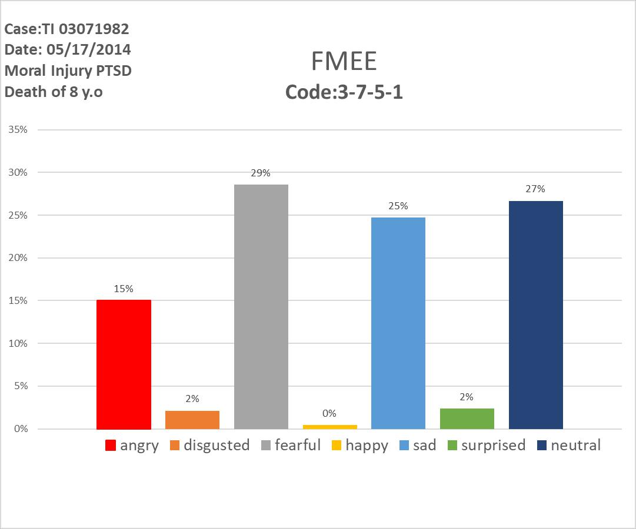

Fig. 8

Here we have the profile of a combat decorated warrior reflecting the most prominent emotions of fear, numbing, and sorrow. The fears he was reporting were fear of betrayal by his wife, or the loss of his child. We needed to review his FMEE Flow to identify a possible source for his reaction (See Fig. 9)
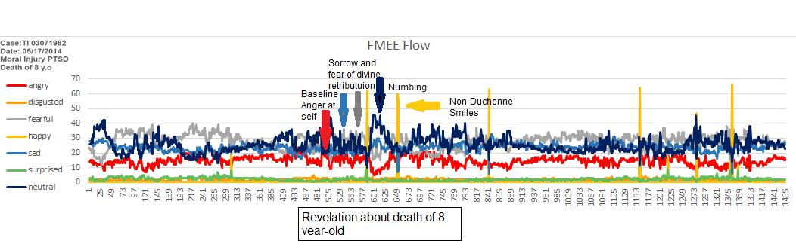

Fig. 9

His FMEEs tracked for everything except for his answer to one question: “Have you ever been in a situation in which you felt responsible for innocent civilian casualties?” He had answered that one question with a “Yes” but said it was “just part of what happens in

WHITE PAPER MAY 2019 | 11

war”. We followed up with more detailed inquiries about what had happened. This is the story he told:

Lance Corporal T’s squad had been manning a checkpoint when a pickup truck approached full of men yelling and waving their arms in agitation and distress. There was an ongoing fire fight in progress behind them on the same road. LCpl T held them at bay with his weapon pointed at them. After several minutes he and his team came to understand there was a wounded eight year- old boy in the truck, and the men, the boy’s relatives, were begging the marines to save him. By the time medical help arrived, the boy had died in LCpl T’s arms. Now LCpl T was a battle-hardened soldier, but he had a son that same age.

This hardened warrior had suffered a moral injury by not being able to save the child. On a level deeper than language it seemed as though he felt he didn’t deserve to have a loving wife or home. Possibly he felt if he returned to his family, his son would die in some form of divine retribution.

See Fig 10 for a screen shot of his facial micro-expression of emotion immediately after he’d made his comment about what happens in war. LCpl T was a fierce warrior, decorated for his bravery under fire, but fighting in a guerrilla war in which protecting his

comrades at arms from a potential car bomb attack made him (in his mind) responsible for an eight-year-old child bleeding out wasn’t his kind of war. He wept as he told the story. He said “I did something that was against everything I learned was right growing up. It was against everything I believed in.” He was the kind of man who saved children, not watch them die while he did nothing.

Because he could see his feelings plotted out as hard data LCpl. T could begin to work on the inner conflict between his having done what he HAD to do, and what his gut told him was right. His first emotional breakthrough came when he realized the therapist reviewing the data with him not only accepted him, but felt deep compassion for his pain as
together they looked at what the FMEE Flow data told them.

Once LCpl. T recognized the source of his trauma, and been supported and accepted by someone else (the therapist) as he dealt with it, he began to heal. He grieved for the dead child, for what he lost in his sense of himself, and for his lost innocence, though it was hard for him to believe he had any innocence left given what he’d already been through before and after that day at the checkpoint. If Face2Face hadn’t opened the window to the

WHITE PAPER MAY 2019 | 12

source of his torment he probably could have undergone months of psychotherapy before the emotional healing process began, if the true causes of his distress were ever uncovered.

Lance Corporal T talked to his military Chaplain, got in touch with the minister from his church back home, and committed himself to helping serve and save children in his community when his tour ended in eight weeks. He called his wife, told her why he had been behaving as he had, wept with her, and told her how much he loved her. After the call, he slept.

The biggest problem in making psychotherapy successful is establishing accurate empathy. Face2Face helped that happen because both the therapist and the patient felt the intensity of the story as it opened up. They were on the same side. The findings from Face2Face deepened the trust between the LCpl and the therapist almost instantaneously because both of them could see what his experience had done to him. When dealing with any change in a service member’s career or assessing his or her ability to carry out the mission, Face2Face is useful for the same reasons. Both the service member and whomever is interacting with him or her are on the same side, looking at hard data that supports accurate empathy.

CASE HISTORY TWO: SGT JEFFREY LEONE

“IF YOU HEAR SOMETHING, SAY SOMETHING”

An opportunity arose in the fall of 2018 to apply Face2Face’s capabilities and in the process possibly save a life. Hueston Middleton, a high official with the US Treasury, had attended a Future Life meeting where he learned about the capabilities of Face2Face. Soon afterwards, Hueston was in Manhattan seated in a sport bar after a long day of work. A man in his late thirties accompanied by a service dog sat down next to him. Hueston began petting the dog and fell into conversation with the man, Retired Marine Sgt Jeffrey Leone. Burly and haggard with a shaved head, Leone was at the end of his rope. During three combat deployments to Iraq at the height of the invasion he had lost 22 friends and been wounded multiple times himself. Since transitioning back, others of his unit had committed suicide.

WHITE PAPER MAY 2019 | 13

Hueston listened as Leone bared his soul. PTSD symptoms had destroyed his life. His wife had left him, claiming that his nightmares, mood swings, and exaggerated startled responses were indicators of violent tendencies. She filed for divorce. Despite the fact he had never been physically assaultive toward her, she obtained a restraining order against him as a “dangerous combat veteran”. Now Leone could only see his sons, ages one and three, a few supervised hours per week. He was angry and depressed. After all he had given to his country he’d been betrayed by friends, family and society. The VA had not been able to provide him with meaningful therapy, maintaining him, instead, on a cocktail of anti-psychotic medications, a virtual emotional straight jacket. He'd recently stopped the medications, telling Hueston, the best action he could now take was to commit suicide.

Hueston asked if he would accept a call from Dr. William d’Alelio, a Future Life researcher and therapist who worked with veterans. When Dr. d’Alelio connected with Leone, Leone agreed to work with the Face2Face technology to map his emotions as he spoke.

Their first Face2Face teleconference map is below - Fig 10:
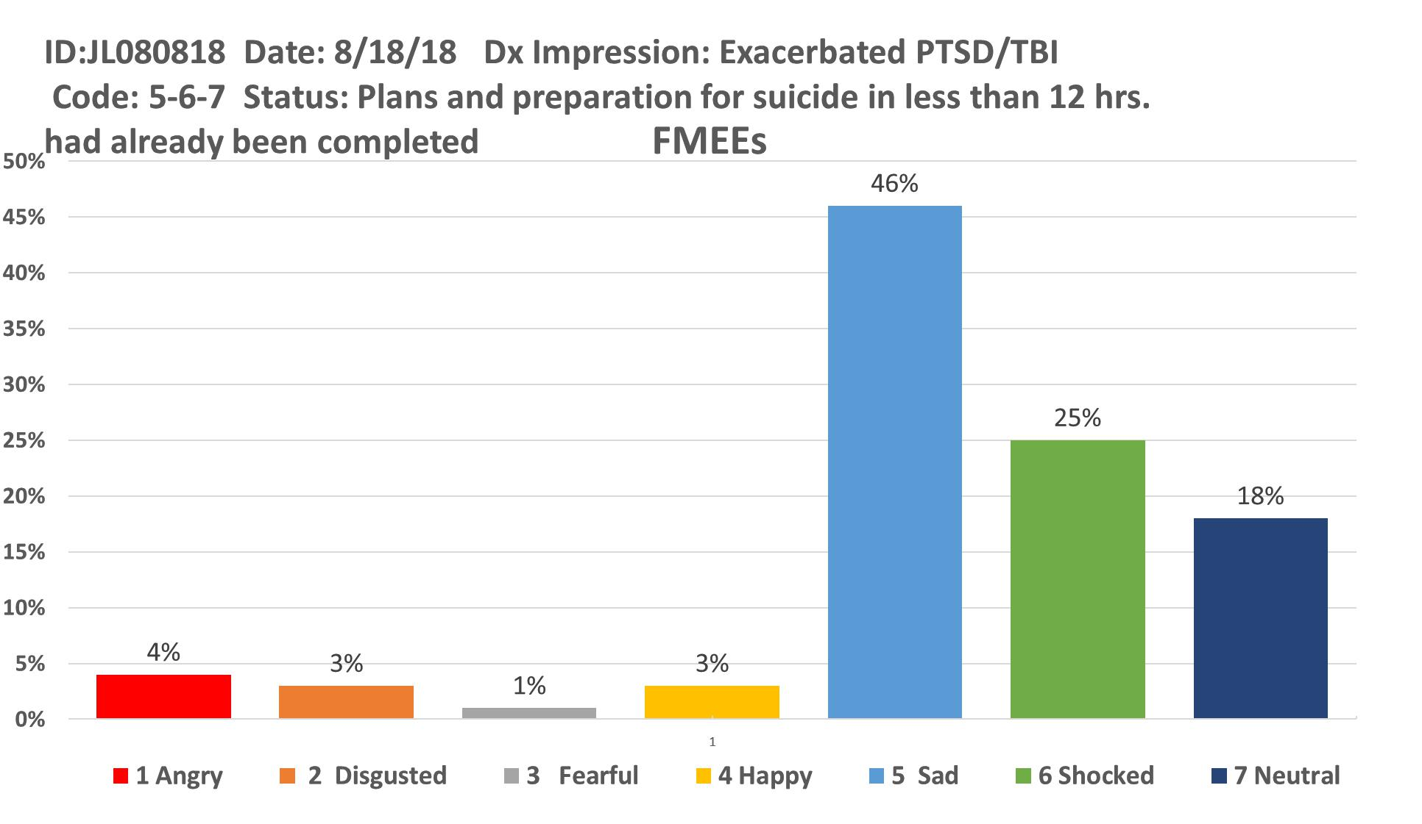

WHITE PAPER MAY 2019 | 14

Fig 10

The map showed that, while Leone was saying he was disgusted and angry at himself and the world and had suicidal ideations, Face2Face data demonstrated a different picture, a portrait of grief and heartbrokenness. Leone was in truth, searching for trust and love. Life had been unfair and unjust leaving him hopeless and sad.

Dr. d’Alelio shared the data with Leone convincing him that his grief illustrated his power to love, starting with himself. He encouraged him to practice mindful meditation and other techniques to help manage his symptoms to begin the healing process.

Eight days later Leone had a second session using Face2Face emotional mapping technology. The second map of emotional data is dramatically different: Fig 11
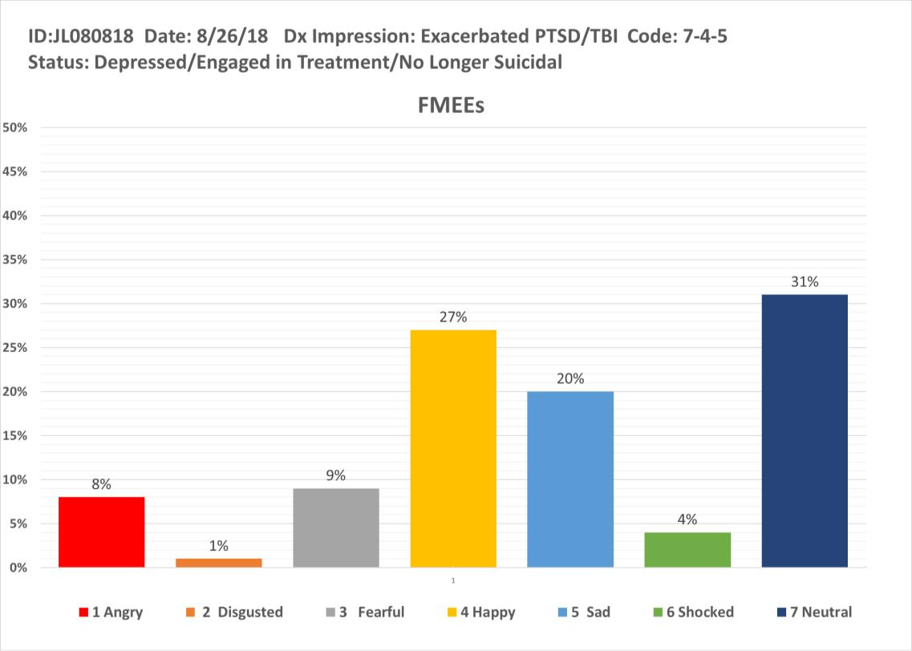

Fig 11

Future Life’s Face2Face technology enabled Leone to look into his unrecognized deepest emotions, to see the truth of his heart, mind and soul. Today Sgt Leone is recovering, working hard to build strong relationships with his sons, and is committed to helping other veterans move from PTSD to Post Traumatic Growth (PTG).

WHITE PAPER MAY 2019 | 15

THREE MAJOR MARKETS FOR FACE2FACE:

The difficulty of having complete mutual understanding of one another’s feelings and motivations isn’t restricted to the work of psychotherapy and emotional healing. Currently Face2Face’s software technology assessment tool, available through leasing agreements, will have significant impact on three major markets: Behavioral Health (Clinical Care), Security (Credibility / Deception Detection), and Human Resources (assessment of, support for, and proper placement for human capital) For markets two and three, Security and Human-Resources personnel, Face2Face measurements will enhance their ability to evaluate the emotional makeup of people for whom they must grant clearance, make a hiring decisions, or match their talents to employment tasks.

- MARKET ONE: Behavioral Health Sciences -

Remote Real Time Assessment for Therapeutic Care – Face2Face technology makes it possible for Behavioral Health Professionals to assess and respond accordingly in real time in one on one sessions with patients or those connected remotely through Internet tools such as Skype, Facetime and Whatsapp. From Veterans to First Responders or Civilians Face2Face gives Behavioral Health Professionals a powerful new tool enabling them to deliver appropriate, instantaneous, empathetic emotional healing.

Administrative Support – Face2Face metrics measure emotional responses to interactions with all behavioral health professionals for purposes of invoicing and documenting sessions. In 2020 the Federal Government will require metrics of this nature when filling for reimbursement from programs such as Medicare, Tricare and Medicaid. It is anticipated that all third party payers including major insurance companies will ultimately adopt this same requirement. Application of Face2Face technology validates behavior health sessions in real time settings on site as well as digitally through Internet visual communications tools such as Skype, Facetime and Whatsapp.

Instead of Fee for Service reimbursement will be based on Quality Value Payments. In other words the better the outcome for a behavioral health care professional’s patients at the most cost effective level, the more the professional will be paid. There are seven important impacts QVPs will have on Behavioral Health.

WHITE PAPER MAY 2019 | 16

1. Quality Value Payments for mental health care are inevitable. Fig 12
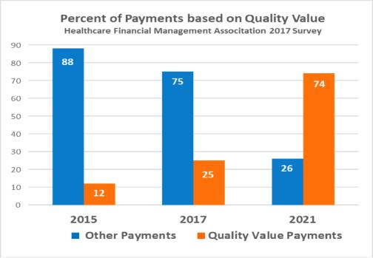

Fig 12

- Quality Value Payments will affect all mental health professions’ reimbursements

WHITE PAPER MAY 2019 | 17
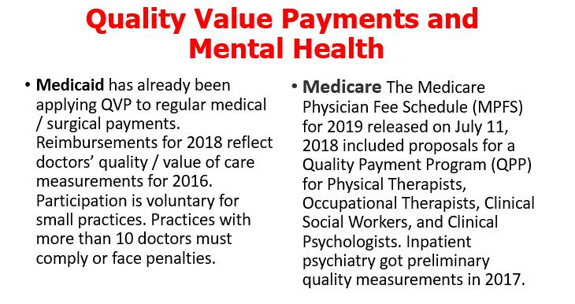

- Quality Value Payments have proven effective and improved health care costs in other specialties and are approved of by CMS (Centers for Medicare & Medicaid) and private insurers. 74 percent of corporate executives report positive financial results from value-based payment programs.

- However, the details of how Quality Value Payments (QVPs) should be determined have not been established by CMS or private insurers even in non-mental health specialties:

- More than 50% of payers are dissatisfied with their value-based analytics, automation, and reporting, even though most were designed and developed in-house.

- There are six key areas of measurement that are earmarked to be prioritized in a QVP for other health specialties. In mental health CMS has come up with metrics for only one, and these metrics are outdated and unrelated to patient outcome. Here they are: Fig 13

WHITE PAPER MAY 2019 | 18

QVP AREA

Efficiency of Care

Intermediate outcome

Outcome

????

Outcome

????

Patient Engagement Experience Treatment Process Structure

Fig 13

Measure Adopted

None

None

Depression remission at 6 mos

or # of Pts on antidepressant Rx >84 days out of prior 114

divided by # of Patients on Rx diagnosed as depressed 270 days earlier

Depression in remission at 12 months

or # of Patients on antidepressant Rx >t 180 days out of prior 231

divided by # of Patients on Rx diagnosed as depressed 270 days earlier

None

None

None

- None of the mental health markers measure or reflect the causes of processes underlying the disorder (in this case only depression) that need to be changed to prevent relapse.

QVP measurements present an administrative conundrum, one that only Future Life’s Face2Face can address. For only Face2Face measures change in emotional self-regulation. Fig 14
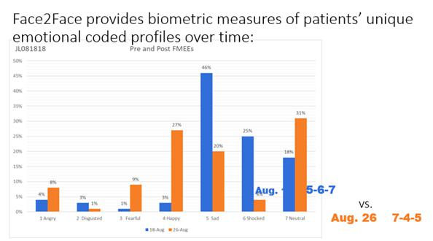

Fig 14

WHITE PAPER MAY 2019 | 19
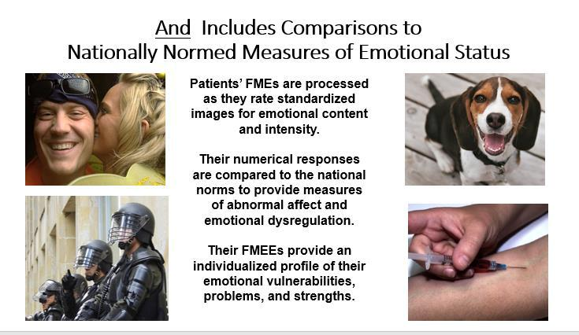

Face2Face gives biometric measurements of patient affect and self-regulation, critical elements in patient recovery and continued wellness, as opposed to the number of days on medication. Fig 15
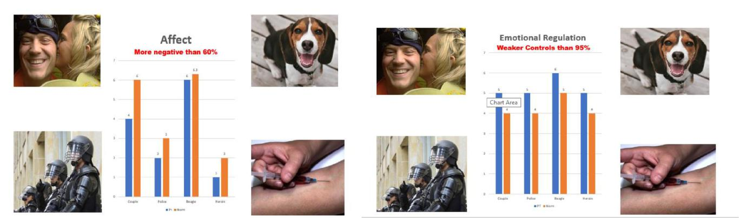

Fig 15

- MARKET TWO: Security and Credibility Evaluation

Face2Face software technology is a tool for Credibility Assessment of individuals who are seeking a position or already positioned in any work that requires security, trust and integrity of character. For example Face2Face could be used to assess the credibility of an individual who is running for office, applying for a law enforcement position, supplying security for individuals, buildings and companies, or applying for a position in government, especially in the areas of intelligence and justice. Face2Face technology is used for:

WHITE PAPER MAY 2019 | 20

Credibility detection
Level of functioning
Deception detection

Internal Uses: Security – modeling and measurement of Credibility Assessment for: EMS, Military, Law Enforcement, Insurance, Sales, Jury Selection or Medical to name but a few.

Face2Face gives Security HR managers a view into the front line readiness of their force. They spot people who are failing or poorly matched to the task and they can identify people who are ready to be promoted.

External Uses: Face2Face gives Security HR managers the ability to measure and map the credibility of individuals before hiring as part of a standard application protocol. This provides a value add in recruitment to local, state and federal entities as well as private organizations.

National Security: Face2Face is a significant compliment to current programs deployed to ensure national security on all levels.

Note:

In Washington, DC at the American University, Department of Psychology,
Interpersonal Emotions Lab, Future Life’s Chief Medical Officer, Dr. William

d’Alelio conducted a 2018 project involving Deception Detection and Face2Face:
Prediction Analysis. The results*proved that Face2Face methodology is
extraordinarily effective at Deception Detection.

*Summary of results available upon request

- MARKET THREE: Human Resources evaluation and employment placement. Face 2Face has unlimited capabilities for assessment of personnel to match task to talent in order to better manage hiring and staffing decisions for both public and private sectors.

The Public Sector: Federal Agencies

Face2Face can be used for pre-employment screening to better match the applicant to a task that increases his / her chance for success and growth. Because it is a tele-health technology easily used by all levels of human resource personnel, it is a Force Multiplier when applied to the Department

WHITE PAPER MAY 2019 | 21

of Defense, Veterans Affairs, Department of State, HHS, DHS, OPM as well as other agencies.

As an example, let’s look at the Armed Services:

Face2Face metrics measure the emotional footprint of all military service personnel including National Guard and Reserve from Recruitment through Separation. Examples of standardized application of Face2Face as integral to Force Readiness/Personal Readiness would be at Basic Training, AIT, before and after Deployment (s), Promotion, Transition from Military Service, Health Benefits Application and more. Face2Face would become as common to military life as the annual physical. For Department of Defense Human Resource personnel and Behavioral Health clinicians Face2Face metrics would truly be a Force Multiplier to be used not only by human resource personnel and behavioral health clinicians to map and assess the emotional state of active duty military but also to assess veterans with mental health problems and military family members.

The Private Sector: Human Resources –

Rehiring, retrofitting people in organizations takes an average of 9 months and costs public and private entities billions of dollars – annually. Moreover the new major workforce, Millennials between the ages of 18 and 38, are staying in a job 4 and ½ years on average. Incorporated as part of the Talent to Task pre-employment evaluation screening Face2Face could improve the chances of success for the new hire, and in doing so save industry time and money each year.

TRAINING:

Future Life Inc. currently offers a two day training course on the Face2Face mapping technology. Originally developed for the Department of Defense, this course is applicable to private sector Face2Face software training needs as well. The course is delivered via classroom and is accompanied by a comprehensive manual in both hard copy and digital formats. Multiple charts, graphs, video clips, and Face2Face FMEE flow charts from clinician/patient assessments, before and after the use of Face2Face technology support the content.

Day One is comprised of ten lessons introducing Face2Face and providing a comprehensive and detailed grounding in its capabilities and applications. Taught by Future Life’s staff of professional Behavioral Health clinicians and former military commanders from both public and private sectors, Day One provides

WHITE PAPER MAY 2019 | 22

questions and answer breaks between lessons as well as ancillary materials such as a sample lesson on Military Families from a second training course focusing on family and community applications of Face2Face. By the end of Day One the learner will be well versed in the background of Face2Face, FMEE flows and how they map emotional landscapes and how the software technology is applied to a variety of use cases.

Day Two is an interactive Lab developed to give students optimal and varied opportunities to work with the Face2Face software technology. Day Two engages the 20 class participants in work groups of four. Lessons one and two are devoted to the technical requirements of video capture and analysis of the FMEE flow results. The remainder of the day is devoted to various exercises using the mapping software. By the end of Day Two the learner will be equipped with hands on experience and be prepared to effectively use the Face2Face software tool in his or her work.

For more information on the Face2Face training program contact: __________

SUMMARY:

In the field of Behavioral Health Face2Face is currently showing revolutionary even disruptive changes to systems of evaluation. For example it is common knowledge that the best solution to our current epidemics of Veteran Suicide and Opioid Addiction is to intervene at the level of preventive care. Acute PTSD should be diagnosed and treated early on rather than waiting for it to become chronic and then attempting a cure. The Face2Face mapping technology assesses the state of mental health illness at both levels, acute and chronic. When the illness is acute, Face2Face measurements offer shared insight to the true causes for the illness to both patient and therapist. When the illness is chronic, the self-awareness and therapeutic alliance capacities of Face2Face make care more effective.

For clinicians doing triage and diagnosis with traumatized patients, even in at remote locations, Face2Face is an invaluable tool as they have to make rapid and accurate assessments of patients’ status.

WHITE PAPER MAY 2019 | 23

Getting it right at this point prevents Acute Stress Disorders from progressing to Chronic or Complex Post –Traumatic Stress Disorder.

Future Life’s Face2Face Application is a game changer. It demonstrates that

telehealth technology leveraged with AI automated analysis of FMEEs can

provide biometric markers of behavioral health or illness. Never before has it been
possible to determine a person’s true emotional makeup backed up with hard
scientific data. While the company’s first focus is Behavioral Health, specifically
PTSD and opioid addiction, solutions to mental health evaluations in the areas of
Human Resources and Security are also on offer using Face2Face mapping

technology through a leasing agreement.
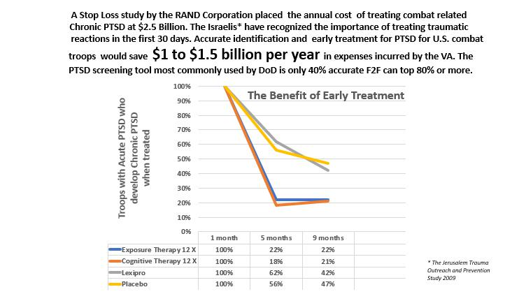

FutureLife Inc chose its name because of the global need for mental health services, security assessors and human resource personnel to use Artificial Intelligence software technology to push into the 21st Century. Face2Face is pioneering transformational technology that processes mapping data in a secure cloud and then returns the results to the user, whether that person is a Clinician, HR manager, Commander, or Credibility Assessor.

WHITE PAPER MAY 2019 | 24

FOR MORE INFORMATION:

Visit _________________

Or email _________

RESOURCES:

- Annie Murphy Paul Mind Reading September 1, 2007 Psychology Today September 2007 edition

- William A. d’Alelio Ph.D. 2016 Facial Micro-expression Analysis of Emotion in Support of Triage, Diagnosis, and Treatment of Post-Traumatic Stress Disorder Of the initial twenty “non-PTSD” combat veterans who volunteered for our initial

Face2Face study between, seven of them had symptoms of PTSD serious enough to warrant treatment. They only recognized they were still carrying emotional wounds from their service when they saw the Face2Face data from their interviews. This 35% rate of stoic denial of emotional distress is typical, if not an underestimate of the percentage of combat veterans with unacknowledged PTSD: Recognizing emotional vulnerability is a luxury not often available to troops in combat, and is definitely not consistent with military culture.

Unpublished White Paper.

- Ekman, P., Sorenson, E. R., & Friesen, W. V. (1969). Pan-Cultural Elements in Facial Display of Emotions. Science,

164, 86-88

- Gabrielle Orum Hernández April 17, 2017Facial Recognition Technology Used in Jury Consulting Lexis/Nexis

- Blum, G., & Schmitt, M. (2017). The nonlinear interaction of person and situation (NIPS) model and its values for a psychology of situations. In J. F. Rauthmann, D.

C. Funder, & R. Sherman (Eds.), The Oxford handbook of psychological situations (pp. 1–17). Oxford: Oxford University Press.

